Meet-information Swedish Swim Games!

Väsby SS has the honor to welcome you to the 2019
Swedish Swim Games, held in Vilundabadet the 28-29th of September.

COMPETITION VENUE |  | Vilundabadet 25 m pool, 8 lanes.
DATES |  | Saturday September 28 and September 29, 2019.
COMPETITION TIMES |  | Friday Training 10.00-20.00
 |  | Saturday prelims: Warmup 08:30-09.45 Start 10:00
 |  | Saturday finals: Warmup 15:30-16.45 Start 17:00
 |  | Sunday prelims: Warmup 08:30-09.45 Start 10:00
 |  | Sunday finals: Warmup 15:30-16.45 Start 17:00
LOCKER ROOMS |  | Follow the signs – Bring padlocks.
PSYCH SHEET |  | The psych sheet will be published on Väsby SS website www.vss.se no later than September 16 2019.
TIMING SYSTEM: |  | Omega Ares.
LIVETIMING: |  | http://livetiming.se/program.php?cid=3702
 |  | Superlive will be broadcast.
WARM DOWN |  | In the two small warm down pools, next to the 25m-pool.
SCRATCHES |  | Scratches are to be turned in 1 hour before the start of each session. Scratches to a final must be turned in no later than 30 minutes after the conclusion of the event.
AWARDS |  | Price money for the top three swimmers in every event!  First place 700 SEK. Second place 300 SEK. Third place 200 SEK.
Prize money, EUR 1000, is awarded to the best female and male swimmers. The FINA Points Table will be used as the basis for deciding the ranking of swimmers.
Also the best FINA points for each day will receive a prize.
 |  | Gifts will be distributed to all medalists.
HEAT SHEETS |  | Every team can pick up heat sheets by the Secretariat. Heat sheets will also be posted around the pool.
CAFETERIA |  | Located in the gymnasium.
HOSPITALITY |  | A coaches hospitality corner will be located in the gymnasium.
PRIZE CEREMONY |  | Prize Ceremony will be in blocks of 4 events i.e after event 1-4, 5-8, 9-12, 13-17, 18-21, 22-25, 26-29, 30-34, see order of events on the next page.

TEAM LEADER MEETING Saturday September 28 at 08.45 in the gymnasium.

CALL ROOM | A call room will be used prior to each final. Each swimmer in the final must report
 | to the call room 5 minutes preceding the event. The call room will be located at the
 | warm down pools. The baskets with clothes will be placed behind the glass wall
 | behind the starting blocks.
FOOD | Food for swimmers and coaches that stays at Scandic Hotel will be served in the hotel restaurant at the following times: Lunch between 11:30-14:30 and Dinner between 18:00-21:00 on both Saturday and Sunday.
LOST & FOUND | Lost and found items will be located in the gymnasium at the help desk.
INFORMATION | Malin Borensjö, E-post: mb@vss.se

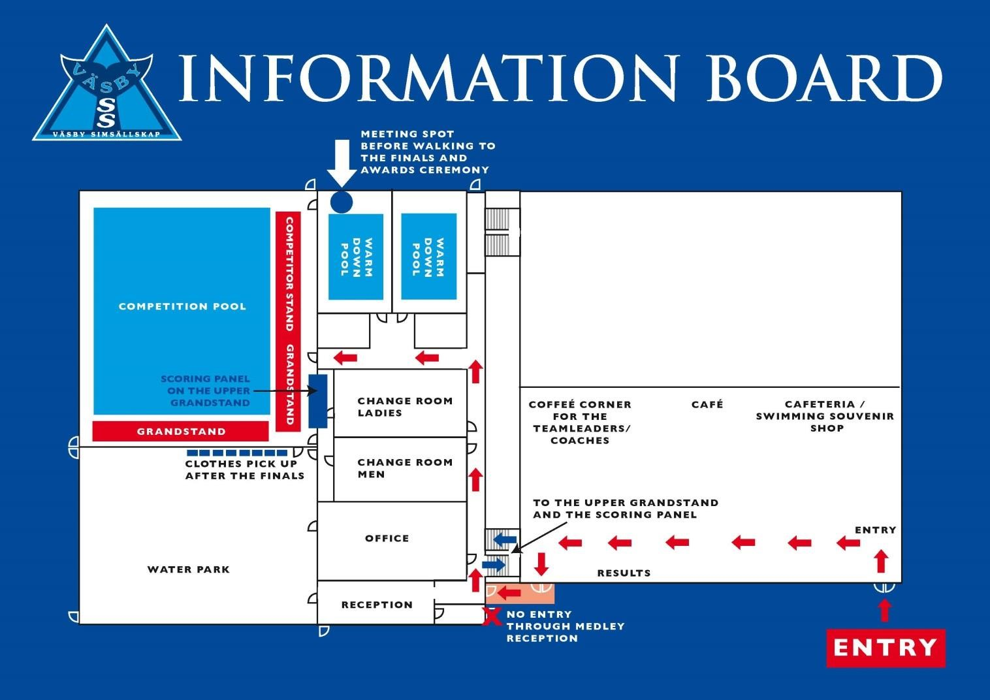

Saturday September 28 | Sunday September 29
Prelims 10.00 | Prelims 10.00
Event 1 800 m freestyle Women | Event 18 1500 m freestyle Men
Event 2 100 m freestyle Men | Event 19 100 m freestyle Women
Event 3 200 m freestyle Women | Event 20 200 m freestyle Men
Event 4 50 m breast Men | Event 21 50 m breast Women
Event 5 100 m breast Women | Event 22 100 m breast Men
Event 6 400 m IM Men | Event 23 400 m IM Women
Event 7 100 m butterfly Women | Event 24 100 m butterfly Men
Event 8 100 m backstroke Men | Event 25 100 m backstroke Women
Event 9 50 m backstroke Women | Event 26 50 m backstroke Men
Event 10 200 m butterfly Men | Event 27 200 m butterfly Women
Event 11 200 m IM Women | Event 28 200 m IM Men
Event 12 400 m freestyle Men | Event 29 400 m freestyle Women
Event 13 50 m freestyle Women | Event 30 50 m freestyle Men
Event 14 200 m breast Men | Event 31 200 m breast Women
Event 15 100 m IM Men | Event 32 100 m IM Women
Event 16 200 m backstroke Women | Event 33 200 m backstroke Men
Event 17 50 m butterfly Men | Event 34 50 m butterfly Women
Saturday September 28 | Sunday September 29
Finals 17.00 | Finals 17.00
Event 1 800 m freestyle Women | Event 18 1500 m freestyle Men
Event 2 100 m freestyle Men | Event 19 100 m freestyle Women
Event 3 200 m freestyle Women | Event 20 200 m freestyle Men
Event 4 50 m breast Men | Event 21 50 m breast Women
Event 5 100 m breast Women | Event 22 100 m breast Men
Prize Ceremony event 1-4  Event 6 400 m IM Men  Event 7 100 m butterfly Women  Event 8 100 m backstroke Men  Event 9 50 m backstroke Women  Prize Ceremony event 5-8  Event 10 200 m butterfly Men  Event 11 200 m IM Women  Event 12 400 m freestyle Men  Event 13 50 m freestyle Women  Prize Ceremony event 9-12  Event 14 200 m breast Men  Event 15 100 m IM Men  Event 16 200 m backstroke Women Event 17 50 m butterfly Men  Prize Ceremony event 13-17 | Prize Ceremony event 18-21  Event 23 400 m IM Women  Event 24 100 m butterfly Men  Event 25 100 m backstroke Women Event 26 50 m backstroke Men  Prize Ceremony event 22-25  Event 27 200 m butterfly Women  Event 28 200 m IM Men  Event 29 400 m freestyle Women Event 30 50 m freestyle Men  Prize Ceremony event 26-29  Event 31 200 m breast Women  Event 32 100 m IM Women  Event 33 200 m backstroke Men  Event 34 50 m butterfly Women  Prize Ceremony event 30-34

Event 1, 6, 18 and 23 will be seeded and swum as timed finals.

